**SQL ORM**

**Youtube Link:** https://www.youtube.com/watch?v=jaKMm9njcJc&list=PL4iRawDSyRvVd1V7A45YtAGzDk6ljVPm1

**How to create a table:**

There are 4 steps for this:

1. Create Engine
2. Create Session
3. Create Table
4. Migrate

**Create Engine----**

Give the path – url—password—dfatabase name





**Create Session:**

First import sessionmaker





**Create Table**

First import declarative base, from sqlaclchemy.ext.declarative import declarative_base

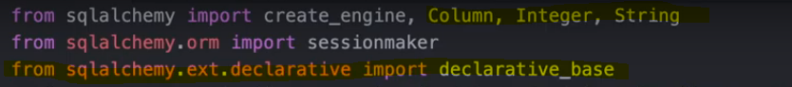

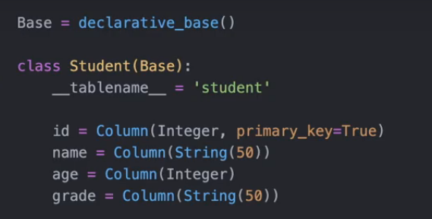

Below command is use to create the table



**Inserting the Record**

1. Create Instances of table class
2. Add data to session
3. Commit changed to database

**Create Instances of table class:**



**Add data to session**



**Commit changed to database**



**If you want to add multiple record at the same time**

Use add_all()

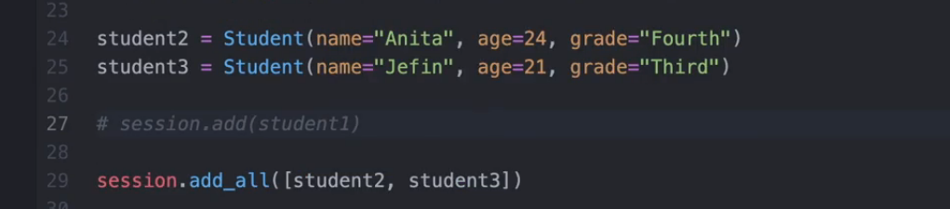

**How to read the data**

1. Get All data
2. Get Data in order
3. Get Data by filtering
4. Count of no of results

**Get All data:**

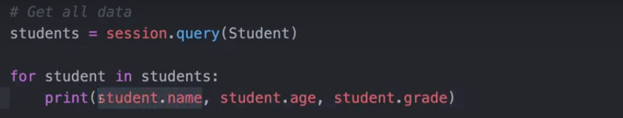

**Get Data in order(Getting the data ordered by student name)**

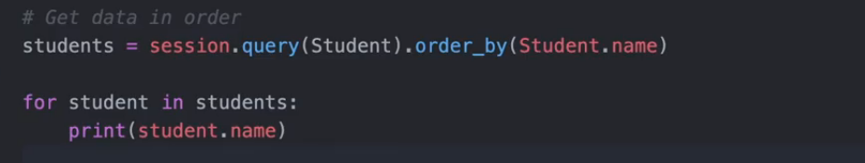

**Get Data by filtering**

1. To find the name Jerkin

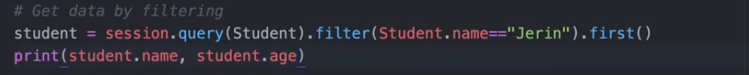

1. Or Operator- Jerin or Anita

There are multiple operator we can check this in documentation

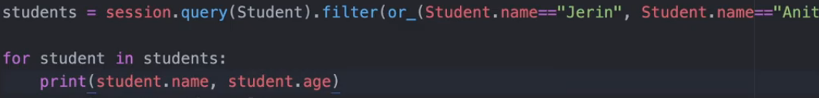

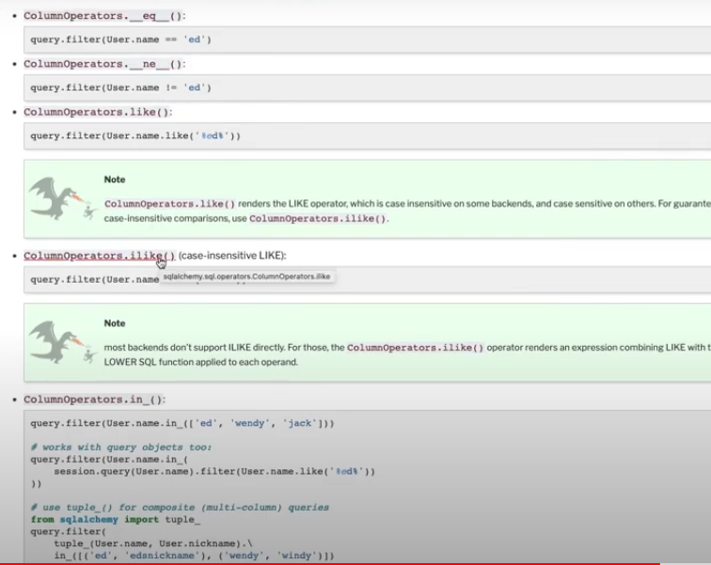

**Count of no of results**

Just need to use **count()** operator

session

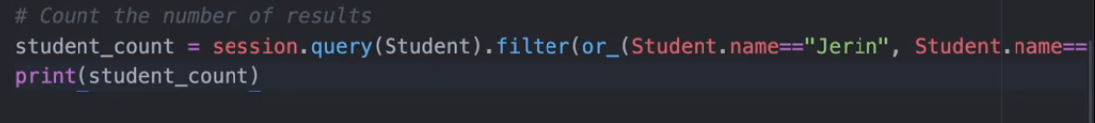

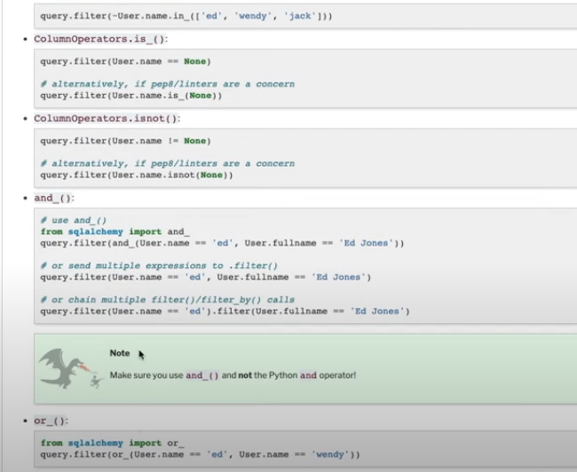

**Update Data in Table**

1. Get Record
2. Change Value
3. Commit Changes

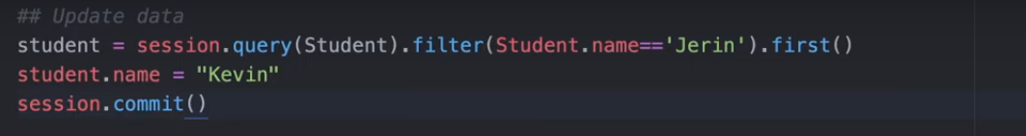

**Delete a Record**

